# MAKING YOUR OPEN ENROLLMENT BENEFIT ELECTIONS USING EMPLOYEE SELF SERVICE (ESS)

Open Enrollment Benefit selections are made using the Employee Self Service (ESS) module in the Enterprise Resource Planning (ERP) system. The ERP system is accessed by clicking on the ERP System link on Insite. If you have problems accessing Insite or ESS, please contact your Department IT HelpDesk.

#### For Prince George’s County Planning:

**To open a ticket, send email to** [PPD.HELPDESK@ppd.mncppc.org](mailto:PPD.HELPDESK@ppd.mncppc.org)

#### For Central Administrative Services:

Create a ticket on ONPOINT Service Desk at [www.mncppc.org/onpoint](http://www.mncppc.org/onpoint) or call 301-454-1040

#### For Prince George’s County Parks & Recreation:

301-454-1515 [itshelpdesk@pgparks.com](mailto:itshelpdesk@pgparks.com)

#### For Montgomery County Parks and Planning:

[mcp-help@mncppc-mc.org](mailto:mcp-help@mncppc-mc.org) 301-495-2540

**PLEASE NOTE THAT YOU WILL HAVE THE CAPABILITY TO VIEW OTHER FEATURES OF ESS AS WELL. THIS GUIDE WE WILL FOCUS ON OPEN ENROLLMENT BENEFIT ELECTIONS.**

**Step 1:** Open Insite by typing [http://insite.mncppc](http://insite.mncppc/) in the browser

**Step 2:** Click on the ERP System icon as shown in the figure below

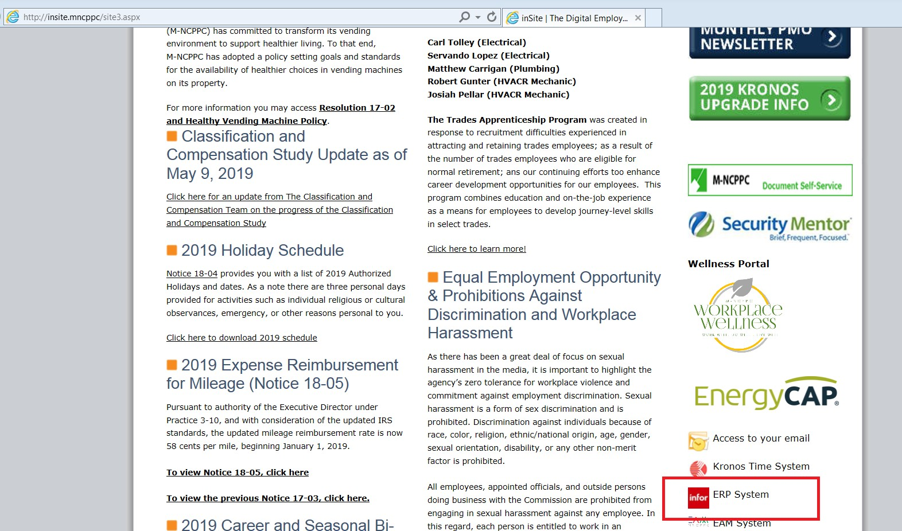

**Step 3:** Click on MNCPPC Azure

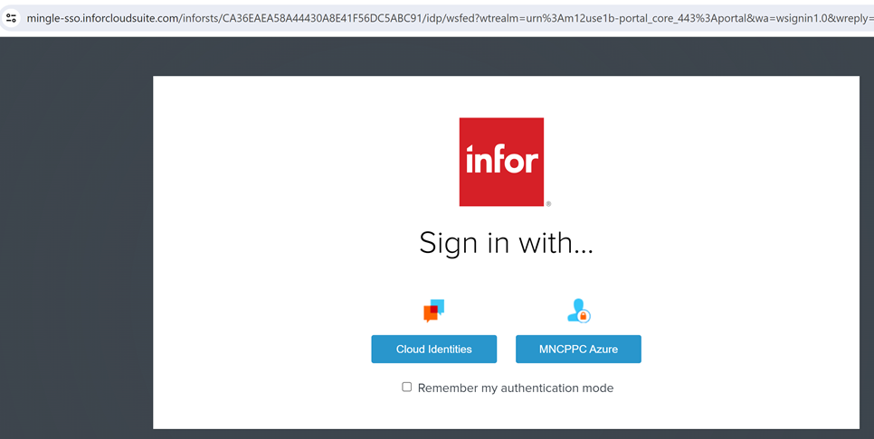

# October 2024

Step 4: Now you will be on the Menu Page. Click on Bookmarks.

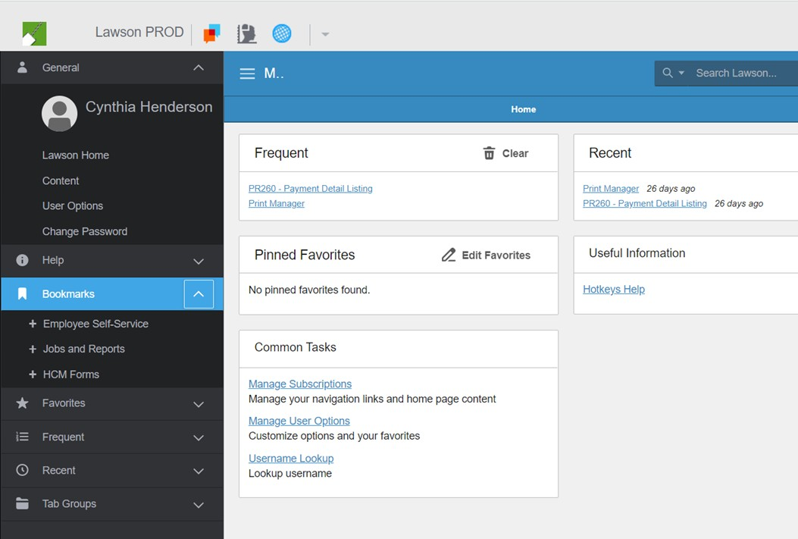

* **Step 5:** Click on Employee Self-Service. (You may see different bookmarks depending upon your access and work programs.)

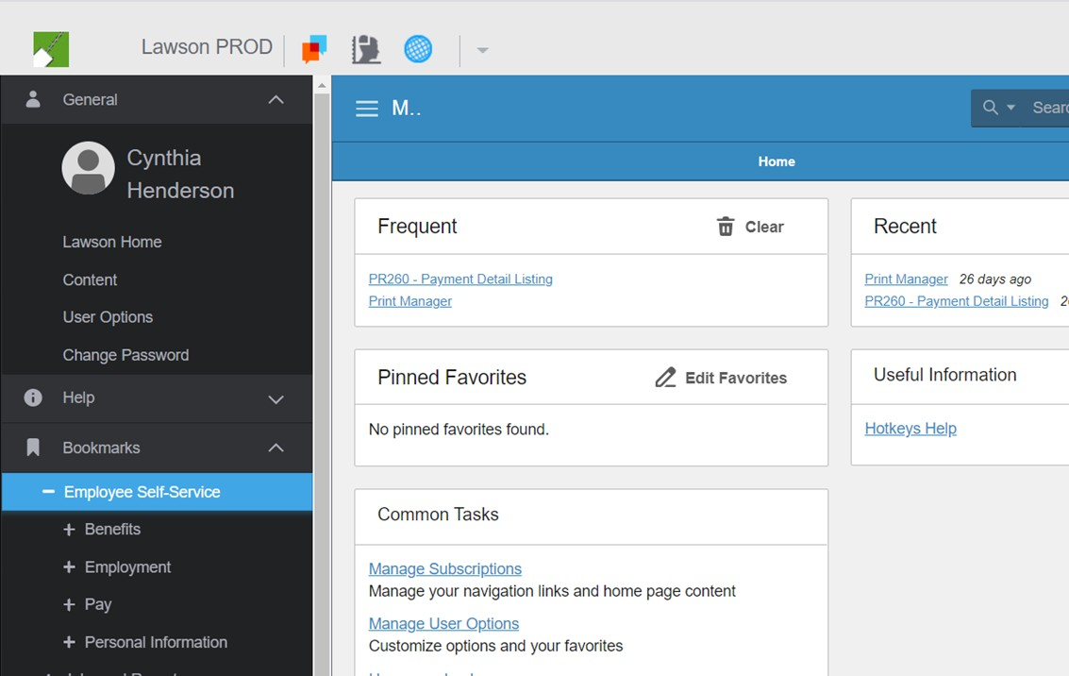

* **Step 6:** Click on **Benefits**:

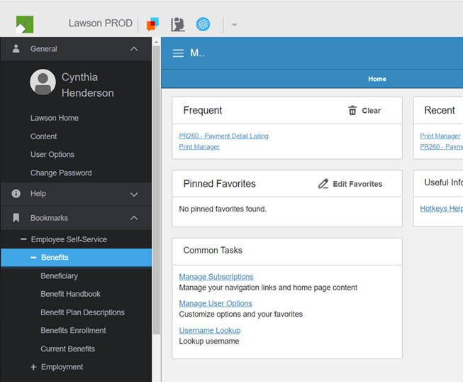

* **Step 7:** Next click on Benefits Enrollment. This takes you to the “Welcome Page” for Open

Enrollment.

* You will begin Open Enrollment at the “Welcome” Page. After you finish reading the instructions on

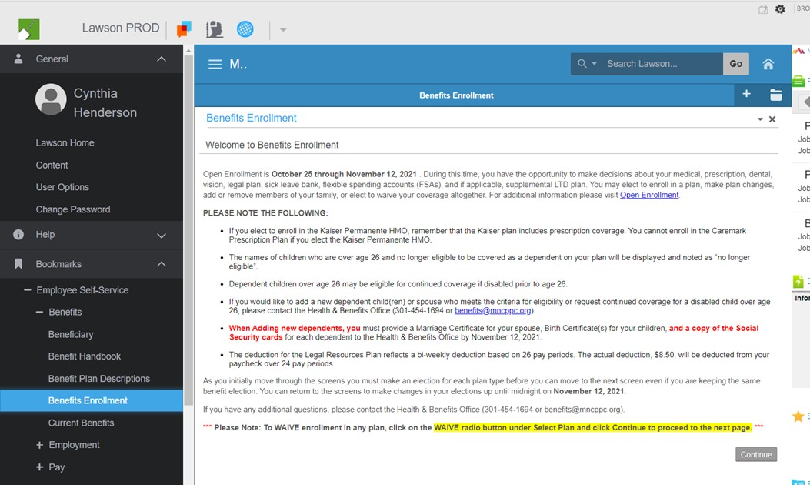

the Welcome Page click the Continue button to take you to the Benefit Enrollment Order Page.

* The Benefit Enrollment Order Page shows you the order of the benefit plans as they will be presented for your election/changes. Click the Continue button to proceed to the Current Benefits Page.

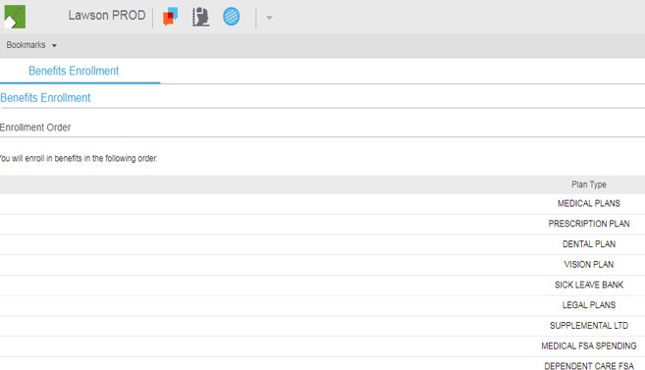

The Current Benefits Page allows you to review the benefits that you are currently enrolled in. Scroll to the bottom of the page and click the Continue button to go to the Medical Plans Election Page.

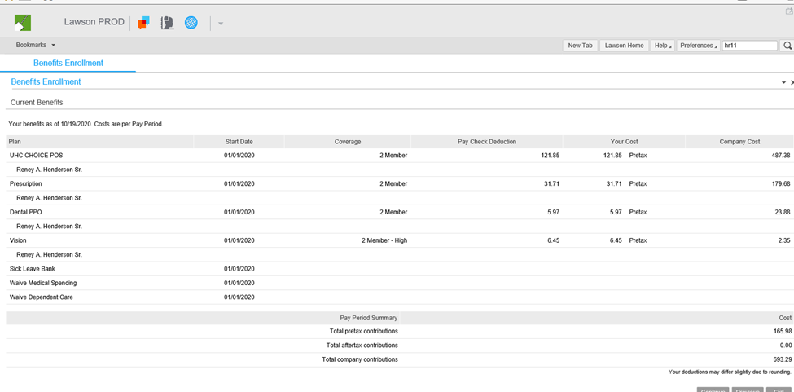

When you reach the Medical Plans Enrollment Election section below, if at any time you want to see details about a specific medical plan, just click on the Plan Name and a window will open with a link for the vendor website or information materials provided by the vendor. Example below:

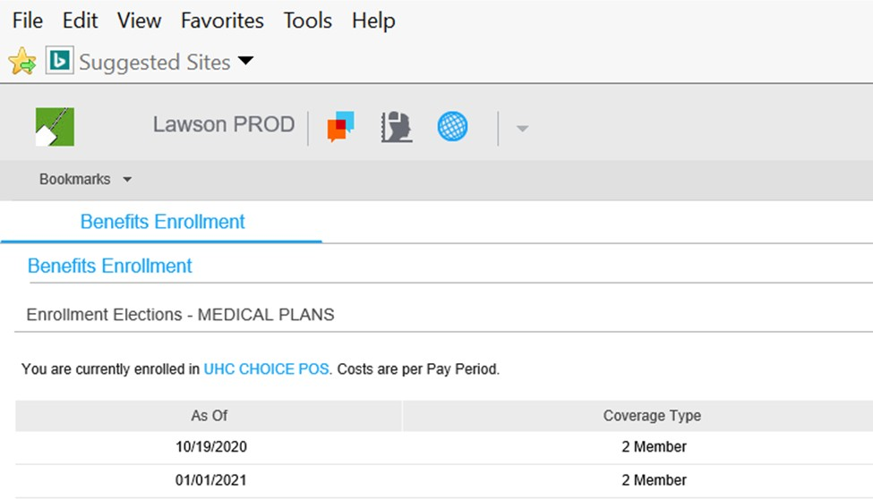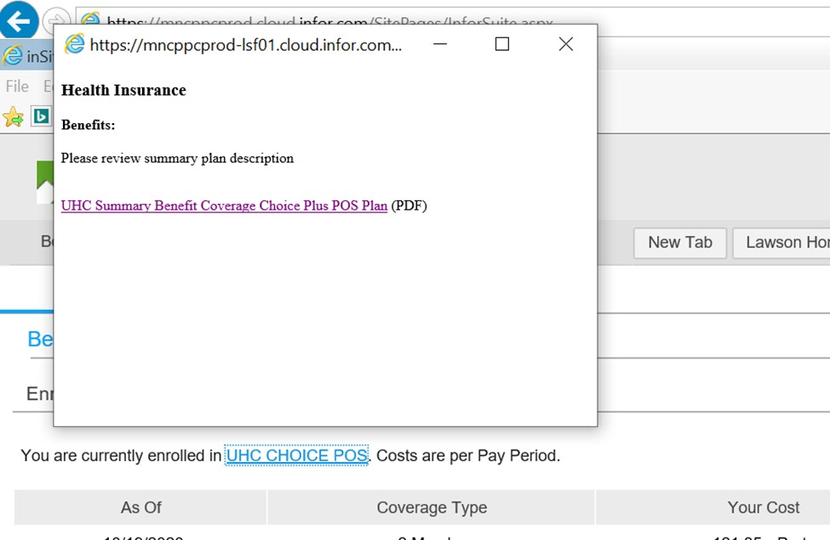

On the Medical Plans Election Page, you must make a selection even if you keep the same benefit.

#### ***Please Note: To WAIVE enrollment in this plan, click on the radio button for “Select a different plan” and proceed to the next page. If you WAIVE a benefit plan, you will not be enrolled in that plan effective 1/1/2025.***

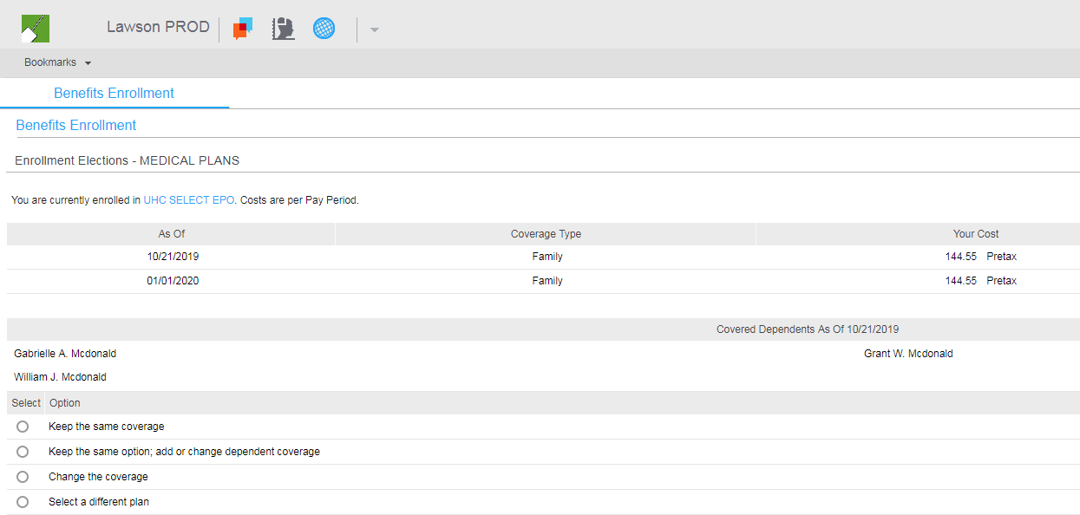

Note: If you change a coverage level you will also be prompted to:

* Select that level: Single, 2-Member or Family with the associated cost and
* Select eligible dependents in the system, if applicable.

If you want to review all plan options before making your final selection, choose “Select a Different Plan”

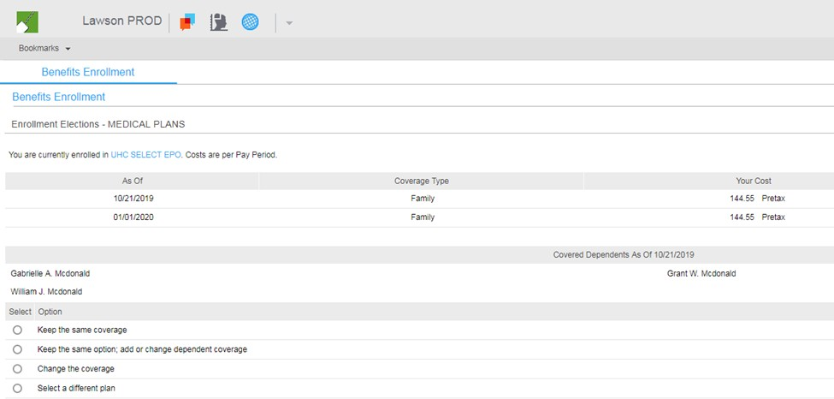

To view all plan options, other than the one you are currently enrolled in, choose “Select a Different Plan” all plan options will be displayed. You may click on any Plan Name and a window will open with a link to more detailed information about that plan.

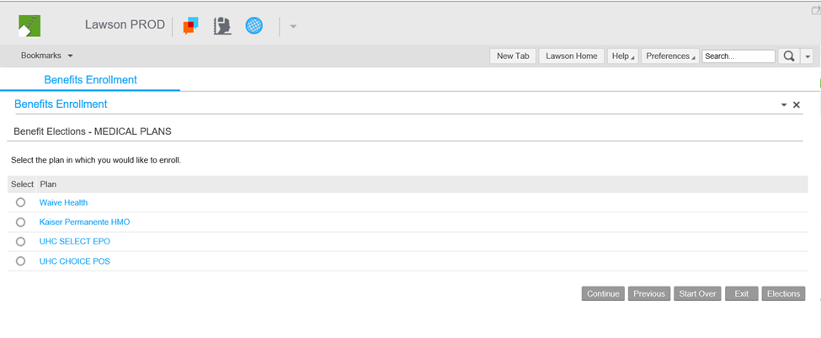

Once you make all selections click the Continue button to display the benefit you selected.

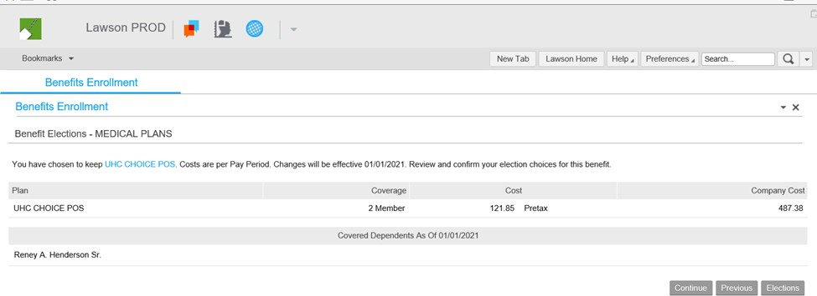

Review your selection for the Medical Plans. If you are satisfied with this election, you may click the Continue button to proceed to the next Benefit Enrollment Election Page for the Prescription Plan.

You may click the Previous button if you want to change your Medical Plan selection at this time. Once you make the change to your Medical Plan, click the Continue button to review your selection. Click the Continue button again to proceed to the next Benefit Plan Enrollment Election Page- Prescription Plan.

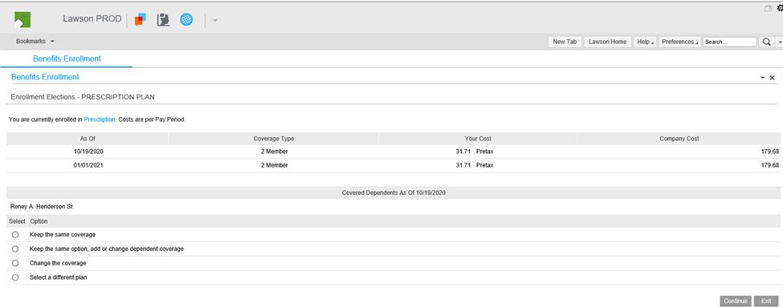

When you reach the Prescription Plan Enrollment Page, if at any time you want to see details about the prescription plan, click on the Plan Name and a window will open with a link for the vendor website or information materials provided by the vendor. Example below:

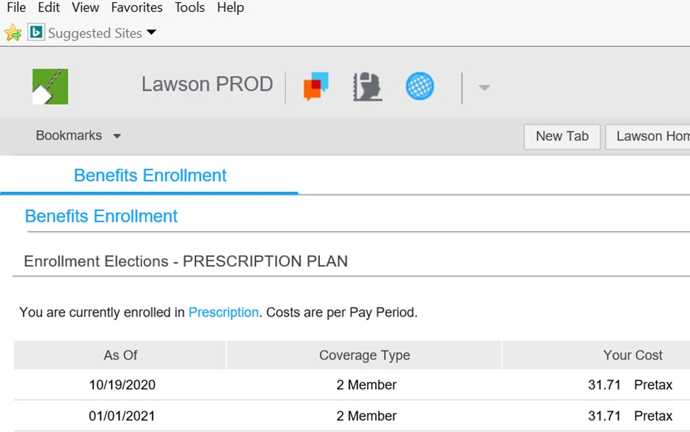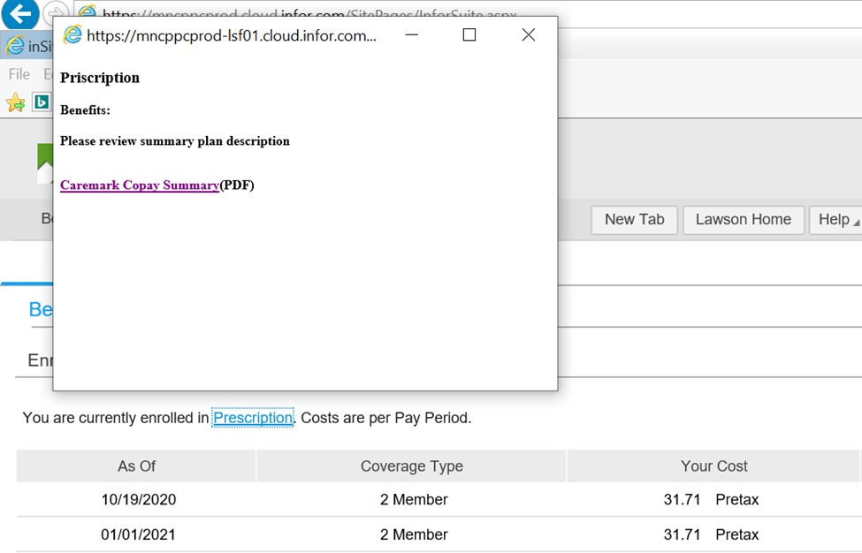

To view all plan options, other than the one you are currently enrolled in, choose “Select a Different Plan” all plan options will be displayed. You may click on any Plan Name and a window will open with a link to more detailed information about that plan.

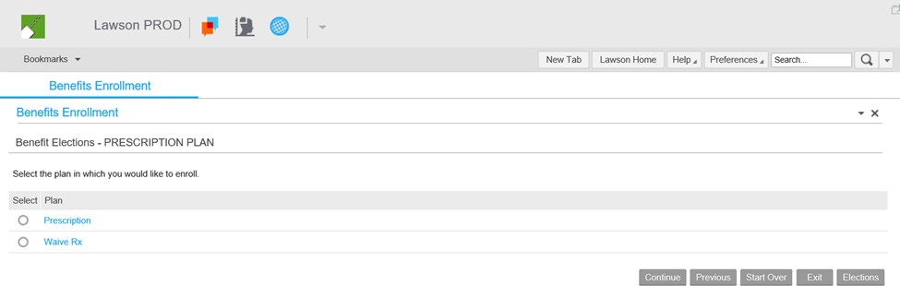

On the Prescription Plan Enrollment Election Page, you must make a selection even if you keep the same benefit. **\*\*\*Please Note: To WAIVE enrollment in this plan, click on the radio button for “Select a different plan” and proceed to the next page. If you WAIVE a benefit plan, you will not be enrolled in that plan effective 1/1/2025\*\*\***

Note: If you change a coverage level you will also be prompted to:

* Select that level: Single, 2-Member or Family with the associated cost and
* Select eligible dependents in the system, if applicable.

Once you make the selection click the Continue button and the benefit you selected will be displayed.

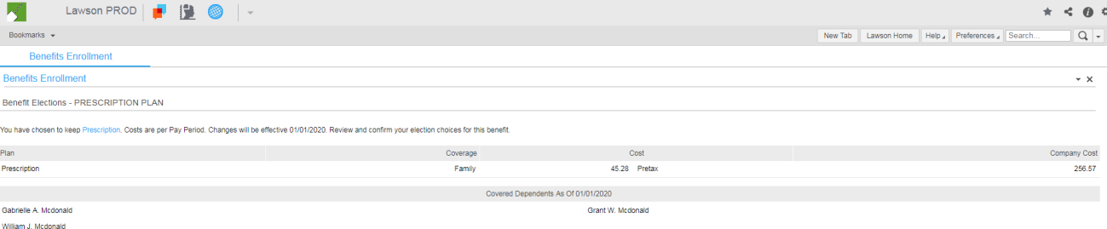

Review your selection for the Prescription Plan. If you are satisfied with this election, you may click the Continue button to proceed to the next Benefit Enrollment Election Page for the Dental Plan.

You may click the Previous button if you want to change your selection at this time. Once you select a plan, click the Continue button to review your selection. Click the Continue button again to proceed to the next Benefit Plan Enrollment Election Page.

***The procedure and screen shots above are for benefit enrollment elections in the Medical Plans and the Prescription Plan. Follow the same procedure for the remaining benefit plans,***

***Dental*, Vision, Sick Leave Bank, Supplemental LTD (if applicable), Legal Plan, Medical FSA Spending and Dependent FSA Spending.***

***\* You have two (2) Dental Plan options: HMO Plan and PPO Plan.***

**\*\*\*\*Remember:** When you reach the Election Enrollment page for any benefit plan and want to see details about the plan, click on the **Plan Name** and a window will open with a link for the vendor website or information materials provided by the vendor.

To view plan options other than the one that you are currently enrolled in, choose “Select a Different Plan” and all options for that particular benefit plan will be displayed.

Once you finish making all plan elections, you will see a summary of your elections on the Benefits Elections Effective as of 01/01/2025.

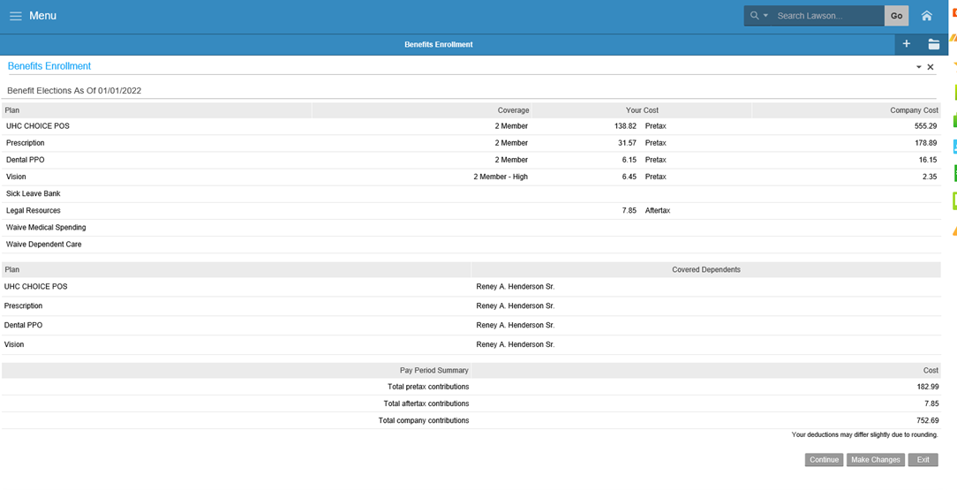

If you are satisfied with your elections, click the Continue button to review and confirm your benefit plan selections that will be effective 01/01/2025. If you want to make changes, click the Make Changes button and update your benefit elections. (See the Making Changes section later in these instructions.)

Warning: If you click the **Exit** button, your elections will not be saved. You will have to start over.

If you are satisfied with your elections that will be effective 01/01/2025 and do not want to make any changes, click the Continue Button to proceed to print a copy.

Click the “Yes” radio button and then click the Continue Button. Retrieve your copy immediately as it contains confidential information.

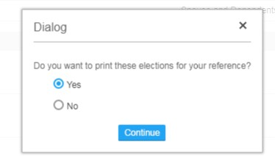

**PLEASE PRINT YOUR SUMMARY PAGE FOR CONFIRMATION AND REFERENCE!!**

Summary Page with Elections Effective 1/1/2025



Once you print your summary page, you will see an Enrollment Elections-Congratulations Page. You have completed your 2025 Benefits Open Enrollment.

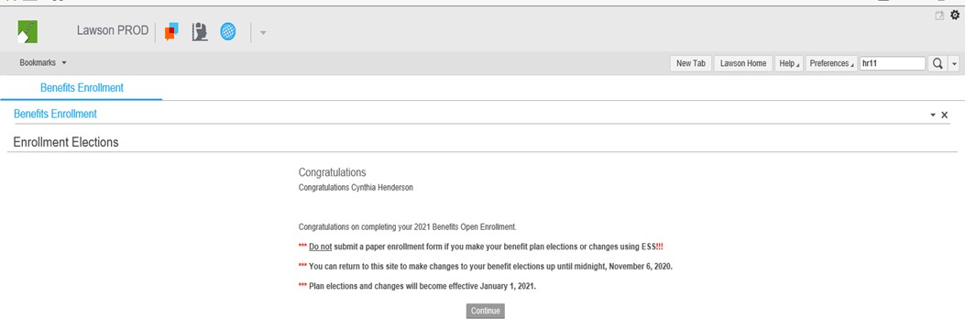

# October 2024

**MAKING CHANGES AFTER YOUR INITIAL BENEFIT PLAN ELECTIONS**

## ***You may make changes to your benefit elections up until midnight, Friday, November 8, 2024***

Access ESS using instructions on page 2-4 of this document. This will take you to the Welcome Page for Open Enrollment.

After you finish reading the Welcome Page click the Continue button to take you to the Current Benefits Page.

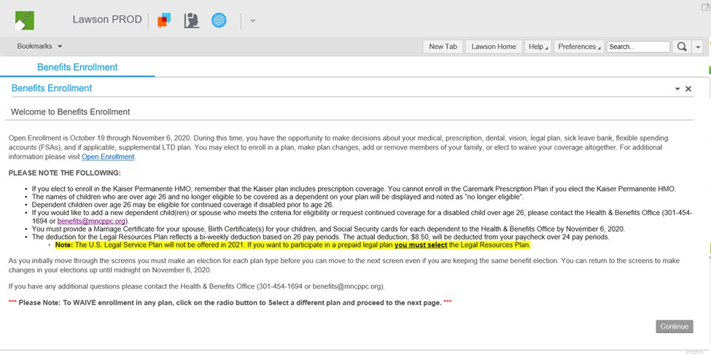

The Current Benefits Page shows the benefits that you are currently enrolled in and the cost.

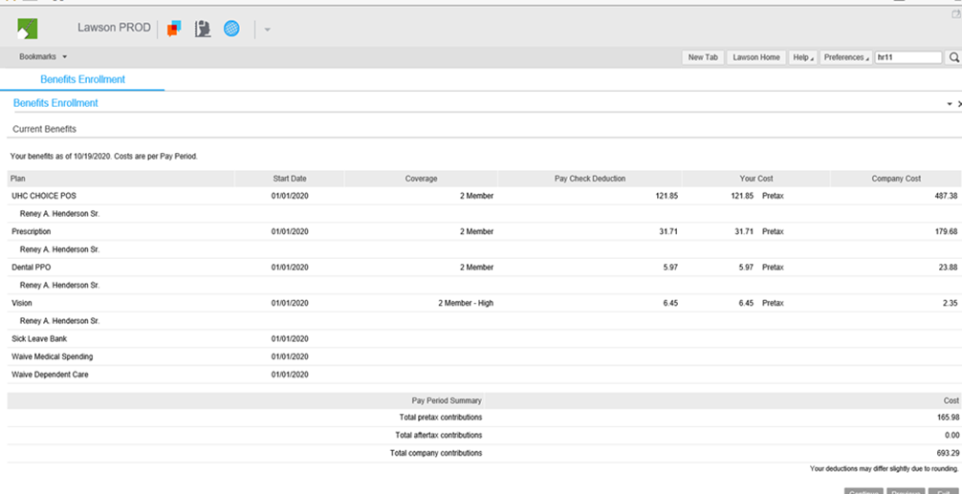

Click the Continue button to proceed to the page for Benefits Elections Effective as of 01/01/2025.



On the Benefits Elections Effective as of 01/01/2025 Page, review your elections. If you want to make changes to the benefits that you selected to become effective 01/01/2024 click the Make Changes button at the bottom right hand corner of the page to go to the Enrollment Change Page.

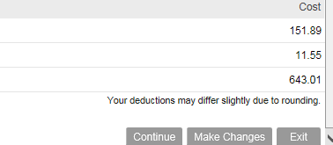

The Enrollment Change Page shows you the list of benefit plans. Place checks only next to the benefit plans that you want to change. In this example, we want to make changes to our elections for the Medical, Sick Leave Bank and Medical FSA Spending Plans. Click the Continue button to proceed with your election changes. (Follow the steps for enrolling in your benefits as before.)

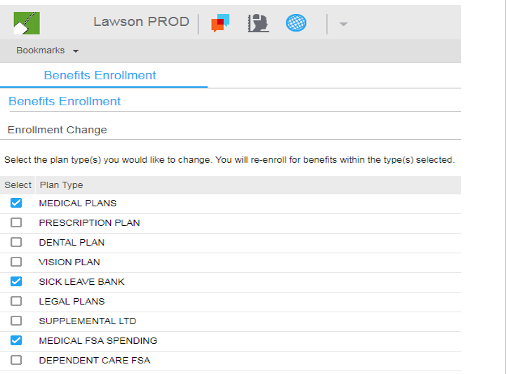

### After you make all of your changes, print (save as PDF) the Summary of Your Elections.

**PLEASE PRINT YOUR SUMMARY PAGE FOR CONFIRMATION AND REFERENCE!!**

**IMPORTANT NOTICE:**

**If you are enrolled in the life insurance plan, don’t forget to review/update your designated beneficiaries using the Beneficiary tab under the Benefits Bookmark. The beneficiaries recorded will be assigned to the Basic and Supplement Life Plans. You are the beneficiary for the Spouse/Dependent Life Plan.**

To review your Life Insurance designated beneficiary, under Employee Self-Service on the Menu, click on Beneficiary and follow the steps.

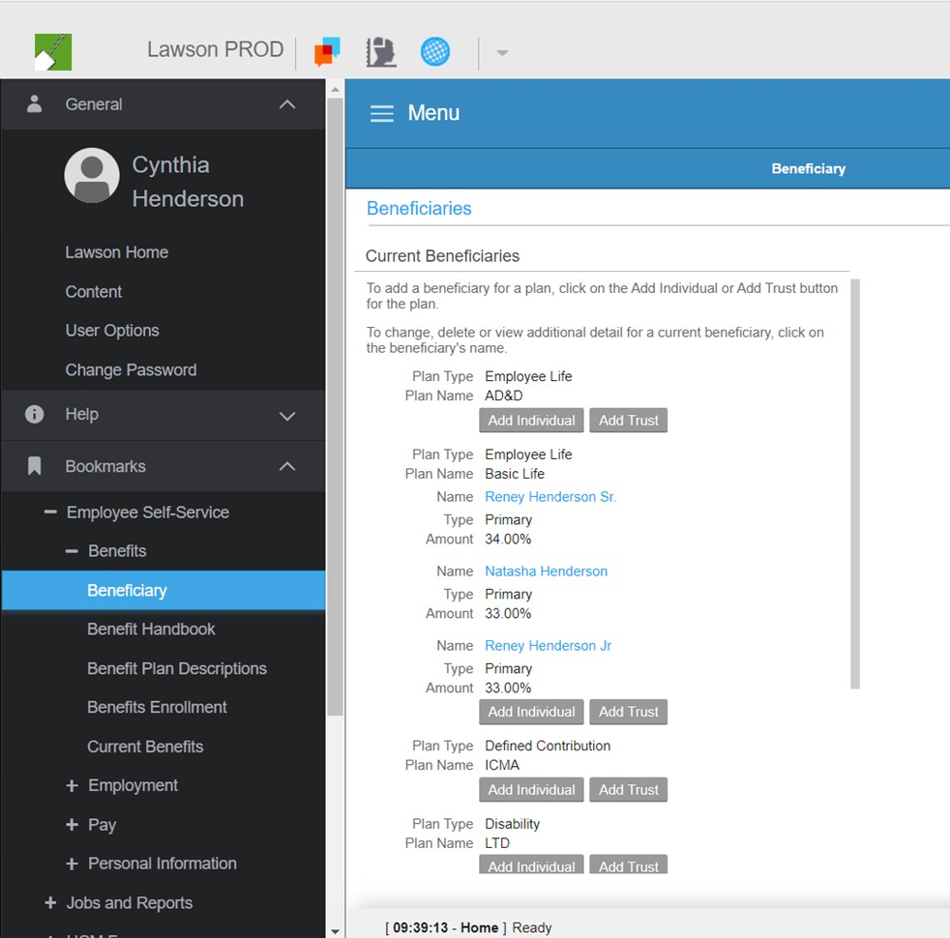

You may use the Beneficiary page to review or update beneficiaries for both the Basic Life Insurance and Supplemental Life Insurance plans. Your current beneficiaries will be displayed. ***(You are the beneficiary for Spouse/Dependent Life insurance.)***

**You can review or update your beneficiaries at any time during the year.**

**If you have any questions, concerning the election of your benefits for Open Enrollment, contact the Health & Benefits Office (**[**benefits@mncppc.org**](mailto:benefits@mncppc.org) **or 301- 454-1694).**