|  |  |  |
| --- | --- | --- |
| The Maryland-National Capital Park and Planning Commission  (M-NCPPC) | | P:\DHRM\MISCELLANEOUS STUFF\DHRM\Policy Specialist Backup Files\11-06-13\New Employee Handbook\Logo.jpg |
| Employee Self Service – Benefits Enrollment | | |
| **Frequently Asked Questions** | | |
|  | | |
|  | | |
|  | October 2024 | |

Table of Contents

1. Technical Questions 4

1.1 What is ESS? 4

1.2 What is online Benefits Enrollment? 4

1.3 How do I know if I am eligible to use online Benefits Enrollment? 4

1.4 Can I use ESS from home? 4

1.5 How do I access online Benefits Enrollment? 4

1.6 What browser do I have to use: Chrome, Internet Explorer, Firefox, Opera? 4

1.7 How do I obtain Chrome or Edge browser? 4

1.8 Can I use ESS from a Mac computer? 4

1.9 I am unable to access ESS – who do I call? 4

1.10 How do I contact IT Help Desk? 4

2. Benefits related questions 6

2.1 I have a question on my Benefits – who do I call? 6

2.2 I am eligible to use online Benefits Enrollment – can I still submit paper forms of my Benefits selection? 6

2.3 I forgot to print my selections – what do I do? 6

2.4 How do I view my current 2022 benefit selections? 7

2.5 How do I view my 2023 benefit selections? 7

2.6 When is the Open Enrollment period? 7

2.7 If I use online Benefits Enrollment, will I get extra time to make my selections? 7

2.8 I don’t have any Benefits changes for 2023 – do I still need to make my Benefits selections? 7

2.9 Do I have to use ESS if all I want to do is re-enroll in FSA and keep all other benefits the same? 7

2.10 What happens if I don’t make any Benefits selections? 7

2.11 I submitted my Benefits selections online and I need to make a change – what do I do? 8

2.12 Why am I not seeing Sick Leave Bank or Supplemental LTD as an option? 8

2.13 Can I update my life insurance beneficiaries using the ESS platform only during Open Enrollment? 8

2.14 Can I make changes once I have entered my elections? 8

2.15 How can I add dependents not already in the system? 8

2.16 Will I get a confirmation email? 8

2.17 What happens if I do not print my elections? 8

3. Appendix A: IT HelpDesk Contact information 9

# Technical Questions

## What is ESS?

ESS is the abbreviation for Employee Self Service. This is a module in the Infor (formerly Lawson) software application being used in the Commission. Infor is the Commission’s Enterprise Resource Planning (ERP) software. The ESS module contains Employee information including Benefits information. For the 2024 Open Enrollment season, ESS is being deployed to Commission employees to allow them to make their 2024 Benefits selection.

## What is online Benefits Enrollment?

The Infor ESS module allows eligible employees to login to their Infor account and make their Benefits selections. Employees can view their current benefits and the changes they have made.

## How do I know if I am able to use online Benefits Enrollment?

First, you must be able to access Infor/Lawson. To be able to use online determine if you can access ESS for online Benefits Enrollment **click here**: [**ESS**](https://nam11.safelinks.protection.outlook.com/?url=https%3A%2F%2Fmingle-portal.inforcloudsuite.com%2FMNCPPCERP_PRD%2Fb8481cd1-dc6d-43f1-a3f6-d5e84ce9028e%3FfavoriteContext%3Dhttps%253A%252F%252Fmncppcprod-lsf01.cloud.infor.com%252Flawson%252Fxbnnet%252Fbenannenroll.htm%2526isHosted%253Dtrue%26LogicalId%3Dlid%3A%2F%2Finfor.lawson-s3.1&data=05%7C02%7Ccynthia.henderson%40mncppc.org%7C0f70daaf0f5347edb56808dce74487cf%7Ca9061e0c24ca4c1cbeff039bb8c05816%7C0%7C0%7C638639528727315455%7CUnknown%7CTWFpbGZsb3d8eyJWIjoiMC4wLjAwMDAiLCJQIjoiV2luMzIiLCJBTiI6Ik1haWwiLCJXVCI6Mn0%3D%7C0%7C%7C%7C&sdata=WUEmEsNgQVSIN8jFwzlxWalQXEeZUiYrdoEQU1YkBI4%3D&reserved=0). If you cannot access Infor/Lawson and this is an error, please contact your IT Help Desk (see item 1.10 for the list).

## Can I use ESS from home?

ESS can only be accessed from computers on the Commission network. If you normally access the Commission network from home using VPN (Virtual Private Network) or other remote access means, then you can use ESS from home.

## How do I access online Benefits Enrollment?

Refer to the [ESS Benefits Enrollment Guide](http://www.mncppc.org/documentcenter/view/21663) for directions.

## What browser do I have to use: Chrome, Internet Explorer, Firefox, Opera?

The preferred browser for using Online Benefits Enrollment is Chrome.

## How do I obtain Chrome or Edge browser?

Contact your Department’s IT Help Desk to obtain the Chrome browser.

## Can I use ESS from a Mac computer?

Yes, you can use ESS using Chrome or Edge browser on any computer that is connected to the Commission computer network

## I am unable to access ESS – who do I call?

Contact your Department’s IT Help Desk.

## How do I contact IT Help Desk?

Depending on your Department, use the following contact information:

**For Prince George’s County Planning:**

To open a ticket, send email to [PPD.HELPDESK@ppd.mncppc.org](mailto:PPD.HELPDESK@ppd.mncppc.org)

**For Central Administrative Services:**

Create a ticket on ONPOINT Service Desk at [www.mncppc.org/onpoint](http://www.mncppc.org/onpoint) or call 301-454-1040

**For Prince George’s County Parks & Recreation:**

301-454-1515 [itshelpdesk@pgparks.com](mailto:itshelpdesk@pgparks.com)

**For Montgomery County Parks and Planning:**

[mcp-help@mncppc-mc.org](mailto:mcp-help@mncppc-mc.org) 301-495-2570

# Benefits related questions

## I have a question on my Benefits – who do I call?

Contact the Health & Benefits team at 301-454-1694 or send an email to [benefits@mncppc.org](mailto:benefits@mncppc.org%20) .

## I am eligible to use online Benefits Enrollment – can I still submit paper forms of my Benefits selection?

Employees are urged to make their benefits selection online using ESS. Employees can also submit manually filled paper forms by mail (postmarked no later than November 13, 2023), email (benefits@mncppc.org ), fax (301-454-1687) or using the secure drop box in the lobby of the Executive Office Building, , but **you cannot not use more than one method.**

## I forgot to print my selections – what do I do?

Login to ESS and navigate to the Benefits Enrollment selection. Your benefits selections for 2025 will be displayed after the screen with your 2024 current benefits displayed. To print the 2025 selections:

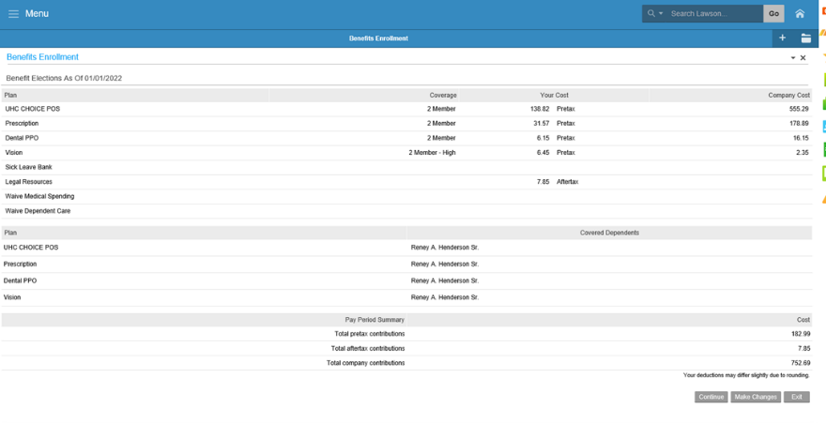

Click on “Continue” at the bottom right hand corner of the page.



* Click on “Yes” and then click “Continue” to print the summary of your 2025 elections.



You can view and print your 2025 benefits selections only during the Open Enrollment period (Oct-21-2024 to Nov-8-2024).

## How do I view my current 2024 benefit selections?

Login to ESS and navigate to the Current Benefits section. Your benefits selections for 2024 will be displayed. You can view your current benefits selections at any time.

## How do I view my 2025 benefit selections?

Login to ESS and navigate to the Benefits Enrollment selection. Your benefits selections for 2025 will be displayed and can be printed by following the steps in 2.3 above. You can view your benefits selections only during the Open Enrollment period (Oct-21-2024 to Nov-8-2024).

## When is the Open Enrollment period?

The Open Enrollment period is from Oct-21-2024 to midnight on Nov-8-2024. While you can access the ESS after 5:00P.M. on Friday, November 8th there will be no technical or benefit support after that time.

## If I use online ESS Benefits Enrollment, will I get extra time to make my selections?

No. You must complete submitting your benefits selection by midnight on Nov-8-2024. It is your responsibility to ensure that you verify ESS access, resolve all system related issues and submit your benefits selections in a timely manner. Extra time will not be provided.

## I don’t have any Benefits changes for 2025 – do I still need to make my Benefits selections?

You do not have to use ESS if you do not wish to make changes. Your current elections will roll over to 2025, **EXCEPT FOR THE FLEXIBLE SPENDING ACCOUNTS (FSA) AND U.S. LEGAL SERVICES).** You must make a new FSA election each year, even if you are electing the same annual contribution. If you want to continue your enrollment in a prepaid legal plan next year, you must enroll in the Legal Resources Plan. Remember, you must remain enrolled in Legal Resources for 12 months before you can cancel coverage.

## Do I have to use ESS if all I want to do is re-enroll in FSA and keep all other benefits the same?

Users have the option to use paper; however, we encourage and strongly recommend using the ESS. You will have to navigate through each benefit plan screen and select the **“No change; keep same plan and same coverage level”** option for all plans until you get to the FSA election screens to make your 2025 elections.

## What happens if I don’t make any Benefits selections?

If you do not make any changes, your current 2024 elections will roll over to 2025 at the new costs, if applicable, **EXCEPT FOR THE FLEXIBLE SPENDING ACCOUNTS (FSA).** You must make a new FSA election each year, even if you are electing the same annual contribution.

## I submitted my Benefits selections online and I need to make a change – what do I do?

You can submit Benefits selections multiple times during the Open Enrollment period. Only the latest successfully submitted selections will be considered effective. Please make sure you print your elections every time you make changes.

## Why am I not seeing Supplemental LTD as an option?

Only benefit plans for which you are eligible will be displayed. Your base annual salary must exceed $108,000 in order to be eligible for the Supplemental LTD plan.

## Can I update my life insurance beneficiaries using the ESS platform only during Open Enrollment?

Life insurance beneficiaries can be reviewed or updated using the ESS platform (Benefits →Beneficiary) at any time throughout the year, not only during Open Enrollment.

## Can I make changes once I have entered my elections?

Yes, you can make changes as many times as you wish up until the last day of open enrollment; i.e., midnight on Friday, November 8, 2024. Print your selections at the end of each session.

## How can I add dependents not already in the system?

You must contact the Health & Benefits office at 301-454-1694 or email us at [benefits@mncppc.org](mailto:benefits@mncppc.org) to submit documents (marriage certificate, birth certificates and social security cards) to add dependents not in the system. The office will review the documents and if acceptable, you will be notified within 2 business days that your dependents were added and you may now access the on-line system to resume your benefits elections.

## Will I get a confirmation email?

No, but you can print your selections at the end of the session or log back into ESS to view selected changes.  Each time you make changes you can print the new selections.

## What happens if I do not print my elections?

Your elections will be processed even if you choose not to print them at the end of the session. You can always log back into ESS to view selected changes.

# Appendix A: IT HelpDesk Contact information

**For Prince George’s County Planning:**

To open a ticket, send email to [PPD.HELPDESK@ppd.mncppc.org](mailto:PPD.HELPDESK@ppd.mncppc.org)

**For Central Administrative Services:**

Create a ticket on ONPOINT Service Desk at [www.mncppc.org/onpoint](http://www.mncppc.org/onpoint) or call 301-454-1040

**For Prince George’s County Parks & Recreation:**

301-454-1515 [itshelpdesk@pgparks.com](mailto:itshelpdesk@pgparks.com)

**For Montgomery County Parks and Planning:**

[mcp-help@mncppc-mc.org](mailto:mcp-help@mncppc-mc.org) 301-495-2570