NOW YOU CAN VIEW A VIDEO OF THE 2019 OPEN ENROLLMENT INFORMATION SESSION HELD FOR EMPLOYEES AND RETIREES AT THE LINKS BELOW. HEAR THE HIGHLIGHTS AND SEE PRESENTATIONS BY YOUR PLAN REPRESENTATIVES FROM UNITEDHEALTHCARE, KAISER PERMANENTE, DELTA DENTAL AND EYEMED.

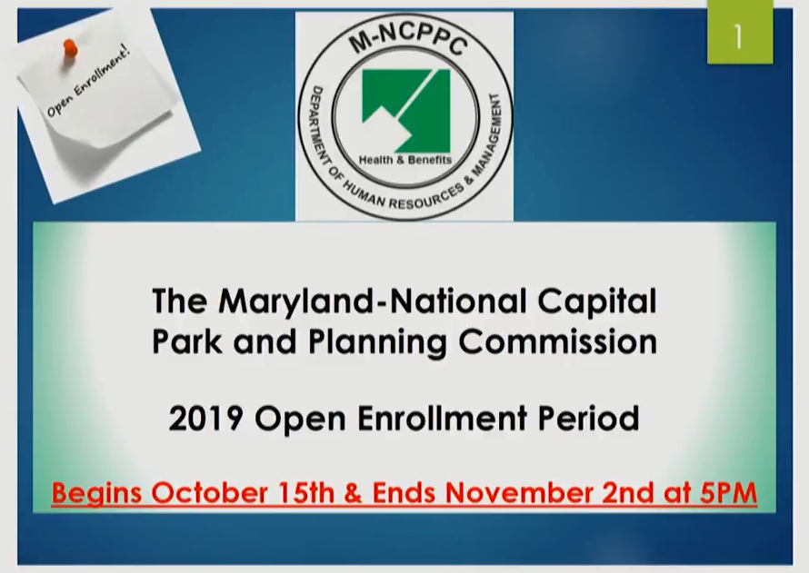

- EMPLOYEES (Ctrl + Click below)

  - 10/15/2018 (MRO) - Employee Session Part I

  - 10/15/2018 (MRO) - Employee Session Part II

- RETIREES (Ctrl + Click below)

  - 10/18/2018 (PRA) - Retiree Session Part I

  - 10/18/2018 (PRA) - Retiree Session Part II

